Digital Entrepreneurship for Women: Longford Women’s Link joined the online Kick-Off Meeting of DEW
On November 10th 2021 Longford Women’s Link led the online Kick-Off Meeting of the DEW project, co-funded by the Erasmus Plus Programme of the European Commission, which brings together seven organisations from five European countries (Ireland, Belgium, Italy, Spain and France). The KOM, originally planned in Brussels, Belgium, was held in online mode due to COVID-19 restrictions.
The context for DEW is based on a number of trends - according to official reports of the EU Commission, only 30% of start-up entrepreneurs are female, despite woman making up 52% of the population. In addition, gender stereotypes and male-dominated models and networks continue to prevail to the detriment of women. Finally, Covid-19 has seen a disproportionate impact on women with increased caring responsibilities and a concerning rise in the incidences of domestic violence.
However the DEW Project explores entrepreneurial opportunity and aims to unlock the potential of female digital entrepreneurs by providing innovative, evidence-based and practical digital entrepreneurship knowledge and tools to empower self-employability and entrepreneurship for women in Europe.
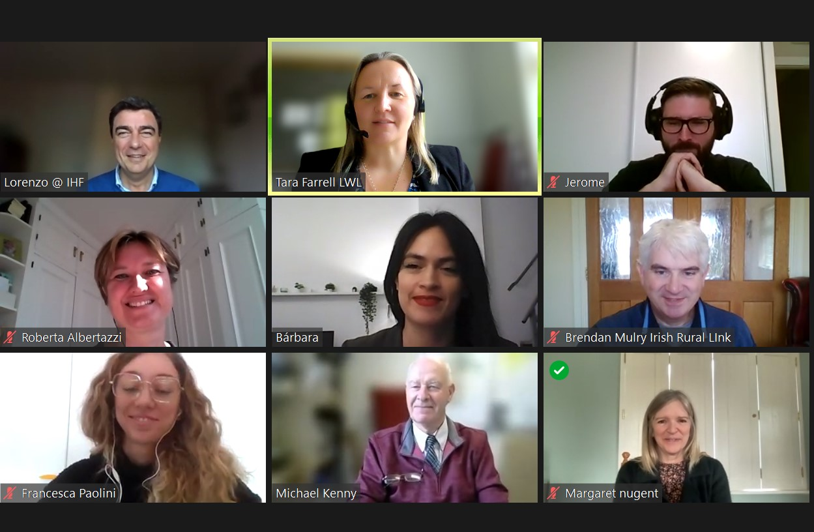
The DEW Project tackles various EU priorities, as well as exploring the impact of Covid-19 on female entrepreneurs:
- the promotion of female entrepreneurship
- the digitalisation of the European population (with specific regard to female entrepreneurs)
- enhancing and boosting the entrepreneurial spirits across the EU
During the meeting, the consortium discussed the overall project implementation schedule, defining timelines and respective duties in the following months. The DEW official website will represent a repository of the project’s outputs, results, news and contacts. A mapping activity will follow in order to identify the main trends, issues, best practices and policy support systems in the countries represented in the Consortium.
This is the third Erasmus+ project for LWL in recent years and the first on which they are the lead partner.
For further information on DEW:
Contact Tara Farrell, 043 3341511
https://www.dewproject.eu/
www.facebook.com/LongfordWomensLink

